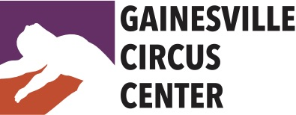

Performance Opportunities

Performances are a vital part of a performing arts education.
We encourage all students to participate in performance opportunities with Gainesville Circus Center (GCC). There are several recurring and spontaneous opportunities to perform each year. It is, however, an immense responsibility. Please read carefully the obligations and terms of agreement.
OBS: Auditions are required all participants in any given performance opportunity unless otherwise noted. Students auditioning for solos must present a minimum of 2 minutes (maximum 4 minutes) of prepared choreography with music. However, it is not required to audition as a soloist in order to participate in a show, however, ALL soloists are required to participate in group acts.

2022 Performance Schedule:

- Swallowtail Farm Festival – April 9, 1pm & 3pm
Audition: video submission to info@gainesvillecircus.com, subject line: Swallowtail Audition. Video must demonstrate complete performance piece (2 – 5 minutes)
Rehearsals: Participants are expected to rehearse independently during open gym. There will be one group rehearsal on April 8 at 6:00pm.
Location: Swallowtail Farm, Alachua, FL

- 5th Avenue Arts Festival – April 23 & 24, exact time TBD
Audition: video submission to info@gainesvillecircus.com, subject line: 5th Ave Audition. Video must demonstrate complete performance piece (2 – 5 minutes)
Rehearsals: Participants are expected to rehearse independently during open gym. There will be one group rehearsal on April 22 at 6:00pm.
Location: NW 5th Ave, Gainesville, FL

- Happy Hour Flying Trapeze Show & Circus Kids, May 21, 5 – 7pm.
Flying Trapeze students interested in being a part of this performance consult with FT staff for participation. A few students from our afterschool circus showcase will be selected to present portions of the afterschool showcase at this event.

- Afterschool Circus Showcase – May 27, 6pm
There is no audition for this event. Performance is open to participants in the afterschool program. Rehearsal is held daily from 3-4pm. Participants must attend at least 2-days per week to participate in showcase. Participants attending less than 2-days per week may be considered for minor roles. Furthermore, students on weekly or monthly afterschool membership are exempt from performance fees for this event only.

- GCC Student Showcase – June 4, 6pm
Solo/Duo Audition: May 13, immediately after ALL cast rehearsal.
Group Audition: Instructor approval with successful demonstration of class choreography May 2 – 6.
Aerial Rehearsals: In-class rehearsals April 4 – June 1.
Group Choreography Rehearsals (required): Fridays 6pm – 7pm & Saturdays 10am – 11am, May 13 – 28.
Tech/Dress rehearsal June 3, 5pm – 8pm

- Circuspalooza - Live Music Circus Show, August 20, 7pm
Our first ever live music student showcase! Music will be preselected for performance. Audition with any music/style of your choice, but be advised, if chosen for performance, you will be given a song to use for the show. You will have the 2 months between audition and show date to work on your piece for this event.
Audition: June 17, 6pm
Rehearsals: Performers are expected to rehearse during open gym. Additional rehearsals with live band will be scheduled - TBD
Tech/Dress Rehearsal, August 19, 6-9pm & August 20, 4pm-6pm
Location: Gainesville Circus Center

7. Gainesville Downtown Festival & Art Show, Nov 19 & 20, 10:30am, 12:30pm & 2:30pm
Audition: video submission to info@gainesvillecircus.com, subject line: GDFA22 Audition. Video must demonstrate complete performance piece (2 – 5 minutes)
Rehearsals: Participants are expected to rehearse independently during open gym. There will be one group rehearsal on Nov 11 at 6pm.
Location: Downtown Gainesville, exact coordinates TBD

8. Two Hawk Christmas Circus, Dec 10, 12pm & 3pm
Auditions: Saturday, Oct 1 @ 10am
Rehearsals: Fridays 6pm & Saturdays 10am, Oct 1 – Dec 2
Tech/Dress Rehearsal at Two Hawk Hammock: Saturday, Dec 3, 1pm – 5pm
No rehearsal Nov 25 & 26
Christmas Circus Performance: Two Hawk Hammock, Williston, FL

9. Afterschool Circus Showcase, Dec 16, 6pm
There is no audition for this event. Performance is open to participants in the afterschool program. Rehearsal is held daily from 3-4pm. Participants must attend at least 2-days per week to participate in showcase. Participants attending less than 2-days per week may be considered for minor roles. Furthermore, students on weekly or monthly afterschool membership are exempt from performance fees for this event only.

Requirements:
Rehearsals
Rehearsals are mandatory to participate in performances unless otherwise noted. Advance notice of absence may be negotiated with GCC, understanding that any performance participation may be reduced to a minor role. Unexcused absences will result in removal from the performance without a refund. Rehearsal tardiness may also result in removal from performances.
Students participating in performances/rehearsals must maintain a minimum of 1/week regular class training. Rehearsals are charged as regular classes – students who train once per week and wish to rehearse for a performance opportunity will need to purchase at a class package that accommodates all necessary training & rehearsal requirements.
Rehearsal schedule is subject to change. Dress rehearsal typically takes place the day before a performance, however, GCC reserves the right to call an additional tech rehearsal within the week prior to the performance. Performers are expected to make every best effort to attend and participate in any additional rehearsals as needed.
Performance Roles
Performance roles will be assigned based on each student’s technique, maturity, availability, and stage experience. Remember: every job is an important one. No performer is guaranteed a solo!
Fees
Participation in rehearsal is required for performance. Rehearsals are charged as classes. Additionally, there is a one-time $125 annual performance fee for participation in any / all of the performance opportunities. Alternatively, students can opt to pay $75 per-performance fee for participation in a single performance. Performance fees are required of all students and staff to cover the costs of event production. Fall Shows: Downtown Arts Festival (Nov 7 & 8) & Country Circus (Nov 13) are each considered 1 performance.
Costumes
Costumes will be provided by Gainesville Circus Center. Costumes must be returned to the GCC wardrobe closet immediately following performance. All performers are expected to supply their own tights, undergarments appropriate to dancewear, and makeup.
Hair and Make-Up
It is the responsibility of each performer to arrive at their performance site with hair and make-up done, or, time permitting, do their hair & make-up onsite. Hair must be secured out of the face with gel/spray, rubber bands and/or pins unless otherwise instructed. Make-up is required for all genders. Make-up style should reflect traditional stage make-up (see below) unless otherwise indicated. Exotic and non-traditional make-up designs must be approved by GCC staff prior to performance. For assistance, please inquire prior to performance date.
Stage make-up examples:
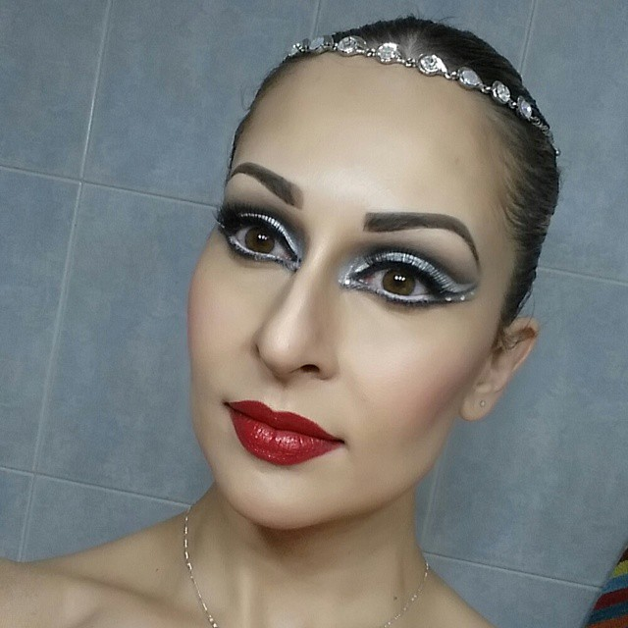

Arrival/Departure/Participation
“Better late than never” need not apply. Rehearsals will begin on time to the minute. There will be a 5-minute grace period for late arrivals. Any performer arriving late more than once may be subject to removal from the performance without a refund. Performances also will be held on time and performers must arrive a minimum of one hour prior to their performance time with hair and make-up done. Once the performance is complete, return all costumes to the wardrobe immediately. ALWAYS bring flip-flops or slip-ons to outdoor shows. NEVER eat in costume.
Set-Up & Break-Down
All adult performers are required to participate in set-up and/or break-down for each performance in which they participate. Set-up and break-down schedules will be determined within a week of each performance date.

Film & Photography
Gainesville Circus Center, Inc & Ascendance Entertainment, LLC often film and/or photograph performances for use as promotional material for future events. By participating in performances sponsored by Gainesville Circus Center, Inc and/or Ascendance Enterainment, LLC, student acknowledges full consent and release of film and/or photographs obtained during performances, which may include the student.
I have read the performance opportunities rules & requirements provided by Gainesville Circus Center.

CUT OFF AND RETURN SIGNED PORTION TO ADMIN
- - - - - - - - - - - - -

I agree to the terms and conditions outlined in the Performance Opportunities 2022 Document and understand that my lack of cooperation and/or participation may result in my removal from any or all performance opportunities. Furthermore, I agree to pay the required performance fee on or before the first rehearsal date.

Student Signature Date

________________________________________________________
Parent or Guardian Signature Date
(If student is a minor)

